

**RC-factory:**

* Beginners /Trainers
* Seaplanes
* Indoor / Parkflyers
* EPP kits of highquality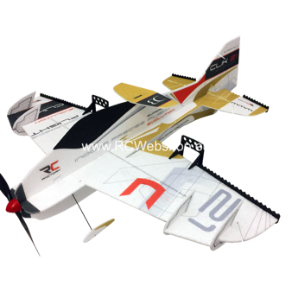



**Robbe :**

* Transmitters
* Aircrafts
* Boats
* Battery's

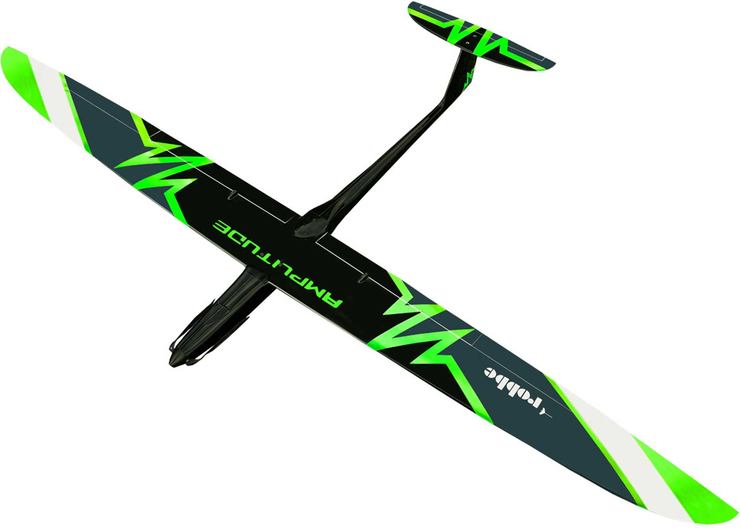



**Jeti Model**

* Transmitters
* Servo’s



**FMS :**

* Jets
* Glider
* Beginners
* Waterplanes
* Trainers

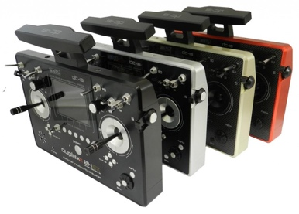

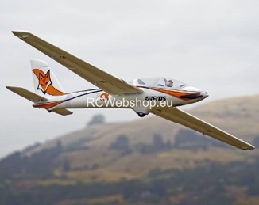

**Need an offer ?**

Scan the QR code

for more info

**Used appliances, electronics and parts**

New stock every week

Scan QR code for more info





**Original Depron Foam**

* For modelling
* 3mm / 6mm
* All dimensions

**www.depron.eu/depron**

**New:**

**Boats, speedboats, scaleboats**

Krick, Robbe, Traxxas, Aeronaut, RBC, Kyosho

**New:**

**Auto’s, Mini Z, Crawlers**

Traxxas, Beast, Kyosho, Losi, Arrma, Tamiya

**Klima Raketenbau :**

* Rockets
* Rocketplanes
* Smoke

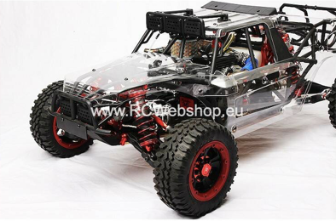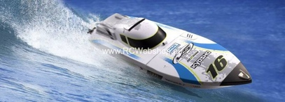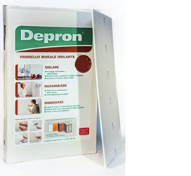



**Value planes :**

* Tiger Moth / Nieuport 28C
* Scale planes
* Large format
* Balsa kits



**Aeronaut:**

* Jets – Gliders – Beginners
* Seaplanes - Trainers
* Balsa kits – no ARF



**RBC models / RBC kits :**

* Jets – gliders – EDF
* Trainers - Delta
* Balsa kits

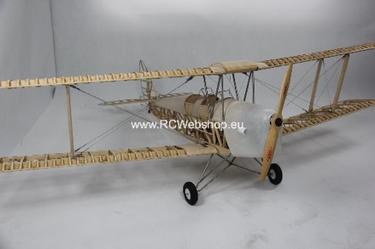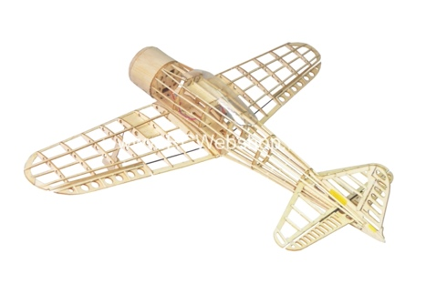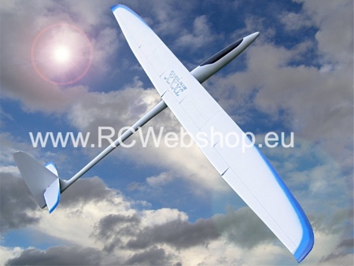****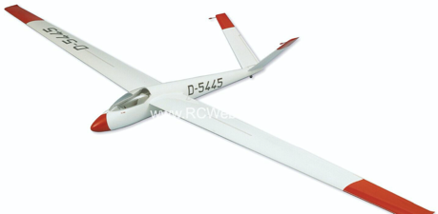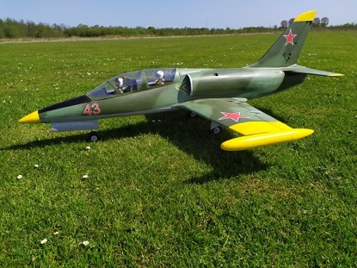



**Micro-Aces :**

* Flying at scale
* Super detailed
* Foam kits / NO ARF

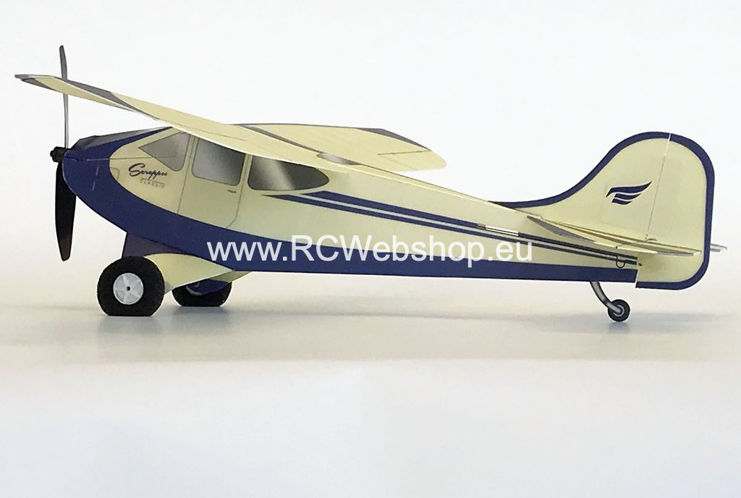­­­­­

**Valenta Model:**

* High quality aircraft
* Sport gliders
* Scale gliders

**Tony Ray's**  **Aeromodels:**

* Mini Micro balsa kits

Micro-electronics in stock